Retired and Senior Volunteer Program: Care Connection for Aging Services

**RSVP Newsletter**

Volume II November 2013 2013

**C:\Users\Deanna\AppData\Local\Microsoft\Windows\Temporary Internet Files\Content.IE5\LXFM473E\MC900053369[1].wmf Giving Thanks…**  As the holidays are here we would like to take this extra special time to say “Thank You” to each of you for the time and service that you give to make a difference.

**9/11 National Day of Service and Remembrance Observed**

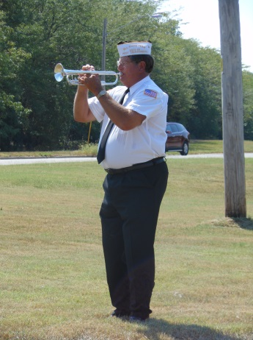

**RSVP** hosted community initiatives in honor of the 9/11 National Day of Service & Remembrance at each of the Benton, Cedar, Henry, Hickory and St. Clair county Food pantries. The events were held the week of September 9th-13th and joined with each city Mayor reading a proclamation and ceremony with VFW Posts or American Legion. RSVP collaborated with local civic organizations and businesses to support the event; raise awareness for communities to unite, put differences aside and join the “I Will’ campaign and do a good deed on 9/11. Lucas Oil Speedway in Wheatland supported the events by providing speedway tickets for a drawing for donors of 3 or more items for each of the pantries.

If you or members of your community are interested in participating in the 2014 9/11 National Day of Service & Remembrance, please contact RSVP at 417-282-RSVP.

C:\Users\Deanna\AppData\Local\Microsoft\Windows\Temporary Internet Files\Content.IE5\XDXN63LX\MC900410541[1].wmf

Volunteer Opportunities:

Be a RSVP Volunteer Ambassador and help us share volunteer opportunities that are available in your community. Meal Drivers, Wellness Class Leaders, Recreation Coordinators, Customer Concierge, Cashier or Kiosk Operators, Benefits Assistance counselor, Tax Assistants, Head Start Helpers or Companionship/Outreach are just a few of the opportunities available.

**Ask us about the details – 417-282-7787**

We would like to welcome . . .

West Central Community Action Agency Head Start Programs in Benton, Cedar, Henry, Hickory and St. Clair Counties as New RSVP Volunteer Stations. Volunteer opportunities with Head Start include: class room assistants, Kitchen/Food assistants and Story Book Readers.

**Meet the RSVP Staff: C:\Users\Deanna\AppData\Local\Microsoft\Windows\Temporary Internet Files\Content.IE5\18S93PXL\MC900430219[1].wmfHeather Kellison**

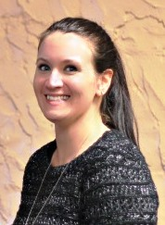Christmas time is upon us once again. Not only is it the time of year for being filled with the Christmas Spirit and helping our fellow man, but it’s also the time of year that can bring out the “not so good” in people. From the stresses of finding that perfect gift to wondering how we are going to pay for that gift it can all be overwhelming.

Being a person easily overwhelmed without the added stress of the holidays, I always try to make the best of “a quick stop at the store” by taking a deep breath and saying to myself, “we never know a person’s struggles so do what Mama taught you, be polite, use manners, and keep smiling”. You never know the impact your warm smile or simple act of kindness can make in a person’s day, or life.

I smiled a lot during that “quick stop” that required my expert Mom skills to maneuver through the sea of carts and I probably overused the phrase excuse me, but I know my mother would have been proud. As I was gathering the winter necessities of dog food and birdseed for my backyard friends, I encountered a rather crowded dog food aisle and it was there all of my positive thoughts were tested. A man bearing a cane crossed my path to get to his particular brand of dog food while urging his wife to hurry with a glare and a gesture. I smiled and said excuse me and quickly tried to get out of their way. I no sooner made it around him when I heard the wife rudely exclaim, “I’m just waiting on traffic.” Knowing she was referring to me I just smiled and continued on. As I was headed to the back of the store to finish my shopping I came upon a gentleman sizing up a large box contain a kerosene heater. There were many people in the store that morning and several in the area where we were standing, yet I was the only person to rush to his side to help him load the rather awkward box. He graciously thanked me and said, “YOU are a good Samaritan.” I replied with, “Thank you, I try to be”.

I’m not sharing my story for recognition of my deeds. I don’t do good to look like a saint or hero. I do good deeds because I have three boys, ages 15, 12, & 4, and I teach them to lead by example. I’m their example and I’m thankful for the generations before me that have served as my example. The truth is that we all need a little help sometimes. We never really know in what form that help may come in. A helping hand, a warm smile, a simple thank you or excuse me may be all it takes to refuel a person’s faith in humanity.

Winter is the time for restoration and renewal, an opportunity to use  
the shorter days and darkness to take care of ourselves, rest and  
contemplate those areas of our lives which require extra nurturing.

**C:\Users\Deanna\AppData\Local\Microsoft\Windows\Temporary Internet Files\Content.IE5\QFJK4443\MC900434463[1].wmf**…Winter is the time for restoration and renewal, an opportunity to use  
the shorter days and darkness to take care of ourselves, rest and  
contemplate those areas of our lives which require extra nurturing.

is the time for restoration and renewal, an opportunity to use the shorter days and darkness to take care of ourselves, rest and contemplate those areas of our lives which require extra nurturing.

**~ Winter Safety Tips ~**

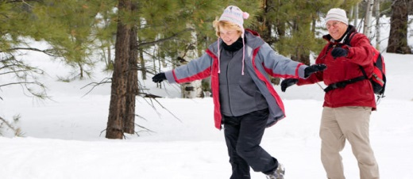**Avoid Slipping on Ice**. Icy, snowy roads and sidewalks make it easy to slip and fall. Make sure to wear shoes with good traction and non-skid soles, and stay inside until the roads are clear.

**Dress for Warmth.** So don't let indoor temperatures go too low and dress in layers. Going outside? Wear warm socks, a heavy coat, a warm hat, gloves and a scarf.

**Fight Wintertime Depression**. Because it can be difficult and dangerous to get around, many people have less contact with others during cold months. This can breed feelings of loneliness and isolation.

**Check the Car.** Driving during the winter can be hazardous for anyone. Checking things like the oil, tires, battery and wipers can make a big difference on winter roads.

**Prepare for Power Outages.** Winter storms can lead to power outages. Make sure you have easy access to flashlights and a battery-powered radio in case the power goes out. Stockpile warm blankets.

**Eat a Varied Diet**. Because people spend more time indoors and may eat a smaller variety of foods, nutritional deficits -- especially Vitamin D deficiency -- can be a problem.

**Prevent Carbon Monoxide Poisoning**. Using a fireplace, gas heater or lanterns can lead to carbon monoxide poisoning. Ensure your safety by checking the batteries on your carbon monoxide detector and buying an updated one if you need to.

**Sense of a Goose:**

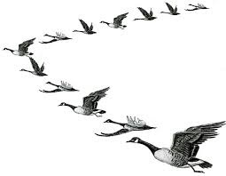When you see geese flying along in "V" formation, you might consider what science has discovered as to why they fly that way: As each bird flaps its wings, it creates an uplift for the bird immediately following. By flying in "V" formation, the whole flock adds at least 71 percent greater flying range than if each bird flew on its own.

*People who share a common direction and sense of community can get where they are going more quickly and easily because they are traveling on the thrust of one another.*

When a goose falls out of formation, it suddenly feels the drag and resistance of trying to go it alone and quickly gets back into formation to take advantage of the lifting power of the bird in front.

*If we have as much sense as a goose, we will stay in formation with those people who are headed the same way we are.*

When the head goose gets tired, it rotates back in the wing and another goose flies point.

*It is sensible to take turns doing demanding jobs, whether with people or with geese flying south.*

Geese honk from behind to encourage those up front to keep up their speed.

*What messages do we give when we honk from behind?*

Finally ... and this is important ... when a goose gets sick or is wounded by gunshot, and falls out of formation, two other geese fall out with that goose and follow it down to lend help and protection. They stay with the fallen goose until it is able to fly or until it dies, and only then do they launch out on their own, or with another formation to catch up with their group.

*If we have the sense of a goose, we will stand by each other like that.*

Winter is the time for restoration and renewal, an opportunity to use  
the shorter days and darkness to take care of ourselves, rest and  
contemplate those areas of our lives which require extra nurturing.

Winter is the time for restoration and renewal, an opportunity to use  
the shorter days and darkness to take care of ourselves, rest and  
contemplate those areas of our lives which require extra nurturing.

Winter is the time for restoration and renewal, an opportunity to use  
the shorter days and darkness to take care of ourselves, rest and  
contemplate those areas of our lives which require extra nurturing.

Winter is the time for restoration and renewal, an opportunity to use  
the shorter days and darkness to take care of ourselves, rest and  
contemplate those areas of our lives which require extra nurturing.

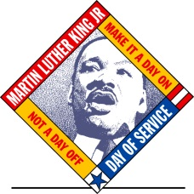

*“WRITE A LETTER” community initiative: On behalf of the RSVP (Retired and Senior Volunteer Program) and Care Connection for Aging Services, we would like to cordially invite you to participate in our support of* ***MLK National Day of Service****; a part of United We Serve, the President's national call to service initiative. It calls for Americans from all walks of life to work together to provide solutions to our most pressing national problems. As a way to pay tribute, RSVP’s community initiative will be sending* ***LETTERS to currently Deployed Service Members and Wounded Warriors*** *through Operation Gratitude.*

*Writing a letter is a meaningful way for Americans to show their support for our Military.*

[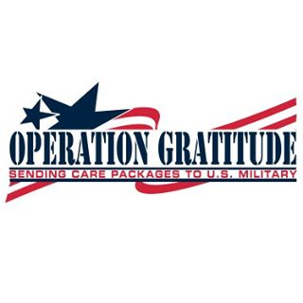](https://www.facebook.com/photo.php?fbid=10151036716412350&set=a.437882232349.238473.54680847349&type=1&source=11)***As MLK day is January 20, 2014, this community initiative begins now and will end January 31st. Letters, artwork and/or cards can be sent or dropped off at the RSVP office 320 N. Main, Wheatland, MO 65779. RSVP will collect, package and send to Operation Gratitude.***

**HELPFUL INFORMATION**-Sample salutations: Dear Hero, Dear Brave One  
-Share a little about yourself: Family, Hobbies, Work or Pets

- Talk about life back home: Sports, Weather, Music, and Movies

- Adults: Include your contact information (mail or email) so the letter/package recipient can reply. Children: FIRST NAMES ONLY with parent mail/email

-No stamps or envelopes needed  
-Hand Written letters or cards are most appreciated

-Still can’t find the words? Consider drawing or painting a picture instead (Please avoid glitter!)

**Our goal is to include several letters and cards in our Care Package and tell our troops “WE CARE!”**

We would be honored to include you in our **MLK Day of Service: “Write a Letter”** community initiative.

For more information please contact RSVP at [rsvpgoaging@centurylink.net](mailto:rsvpgoaging@centurylink.net) or 417-282-7787.

C:\Users\Deanna\AppData\Local\Microsoft\Windows\Temporary Internet Files\Content.IE5\XDXN63LX\MC900304875[1].wmf

For all you are and all you do…

At Christmas and all year, thanks for giving hope and cheer.

We wish you a Very Merry Christmas and a Happy New Year!

Heather & Deanna

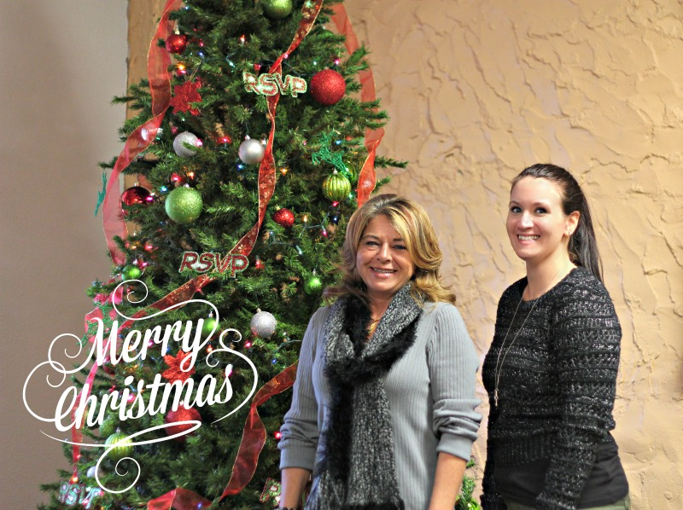

[](https://www.facebook.com/pages/RSVP-Care-Connection/359605747470114)RSVP is looking to ***grow***, ***Grow***, ***GROW***!

We are growing our Facebook page to spread the word about RSVP & volunteer opportunities!

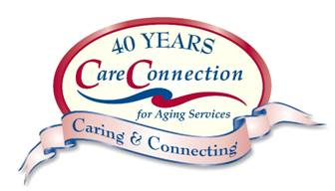Like us on Facebook: RSVP: Care Connection